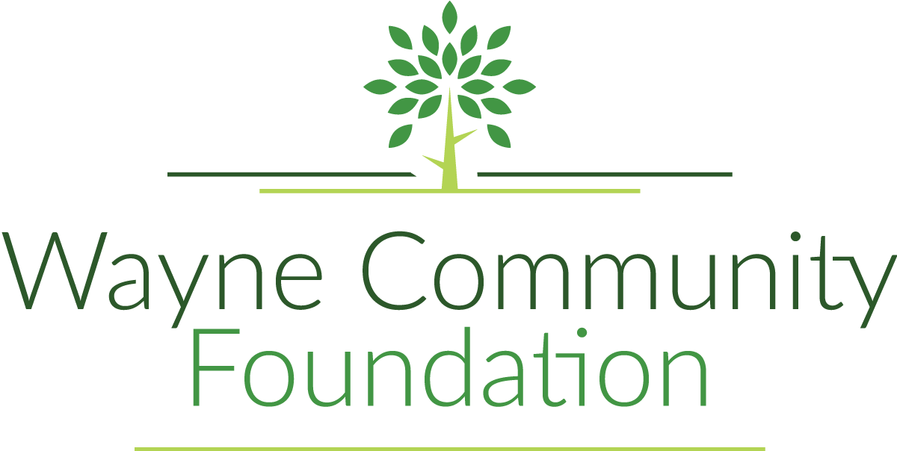

208 S. Franklin St.
PO Box 82
Corydon, IA 50060
641-872-1021
waynecommunityfoundationiowa@gmail.com

Grant Application Overview

Mission Statement: The Wayne Community Foundation is an organization designed to assist and benefit the citizens of Wayne County.

Types of Grants
Grants will be distributed 50% to basic grants and 50% to focus grants. The category for focus grants is health, wellness, and recreation. Applications for basic grants must be for $1,000 or more. Applications for focus grants must be $10,000 or more.

Generally Will Not Fund:

- Existing debt
- Operating expenses, salaries or labor
- Consumable items, freight or shipping

Application Deadline:
February 6, 2023
Will be approved by March 6, 2023
Drop off original plus SIX copies when submitting.

Affiliate Grant Application Contact Information:

Caleb Housh, President
caleb@lockridgeinc.com
641-895-8523

Taylor Bloomquist, Foundation Coordinator
waynecommunityfoundationiowa@gmail.com
319-316-2073
Eligibility to Apply for Funding:

- 501(c)(3) tax-exempt, nonprofit organizations or 170(c)(1) component units of government organizations (Fire Dept., Ambulance, Libraries, Parks, etc.)

- Organizations providing services within Wayne County.

- If you are not a 501(c)(3) or a 170(c)(1), you must align yourself with a fiscal sponsor.

- The Final Report for all previous grants must be on file prior to submitting a new grant application.

Wayne Community Foundation
“An Affiliate of the Community Foundation of Greater Des Moines”
Grant Application – Cover Page
Project Title: |  |  |  |  |  | Date:
Applicant: |  |  |  | Federal Tax ID#:_____________________________  501(c)(3) organization___170(c)1 government___  Other-_______________________
Address:
City: |  | State: |  |  | ZIP Code:
Contact Person Responsible for the Project & their Title:
Contact Phone: |  |  | Contact Email:
Project Budget: $ | Amount Requesting: $ |  |  |  |  | Project Start Date:  Estimated Completion Date:
Type of Grant: ___Basic
___Focus (Health, Wellness, and Recreation)
Type of Project: ___Capital (building of or physical improvement of something)
___Program (operational, activity, general support)
Project Focus Area: ___Arts/Culture/Humanities ___Education ___Environment/Animals ___Health

___Human Services ___Public/Society Benefit ___Other _______________________________

Brief Description of Organization:

Brief Description of Project:

Signature: |  |  | Date:
Drop off completed original application and 6 copies by Monday, February 6th, 2023:
Wayne Community Foundation office
208 S. Franklin St., Corydon, IA 50060
(Between Farm Bureau and Prairie Clover Market)

Please reach out to Caleb Housh or Taylor Bloomquist with questions:
Caleb
caleb@lockridgeinc.com
641-895-8523
Taylor
waynecommunityfoundationiowa@gmail.com
319-316-2073

Wayne Community Foundation
“An Affiliate of the Community Foundation of Greater Des Moines”
Grant Application – Questions of Purpose
Describe the need or problem being addressed by this project:

Explain how this project will benefit the citizens of this county. What area or population is being served?

Describe the project goals and objectives. Describe the steps you will follow to achieve goals and objectives, complete with timeline:

Describe how you will measure the impact/results of your efforts:

Will this project have long-term impact? How will this project be sustained?

Have you previously received funding from Wayne Community Foundation? If so, when?

Project Budget
Income

Source Amount
Individual Gifts | $  4
Sponsor Cash | $
Federal Gov. Grants | $
State Gov. Grants | $
Private Foundations | $
Sponsor In-Kind | $
Private In-Kind | $
County Foundation | $
Other | $
Other | $
Other | $
Other | $
Total:

Expenses

Source Amount
Land Purchase | $
Professional Services | $
Construction Costs | $
Equipment Purchase | $
Construction Supplies | $
Training Costs | $
Personnel Costs | $
Other | $
Other | $
Other | $
Other | $
Total:

