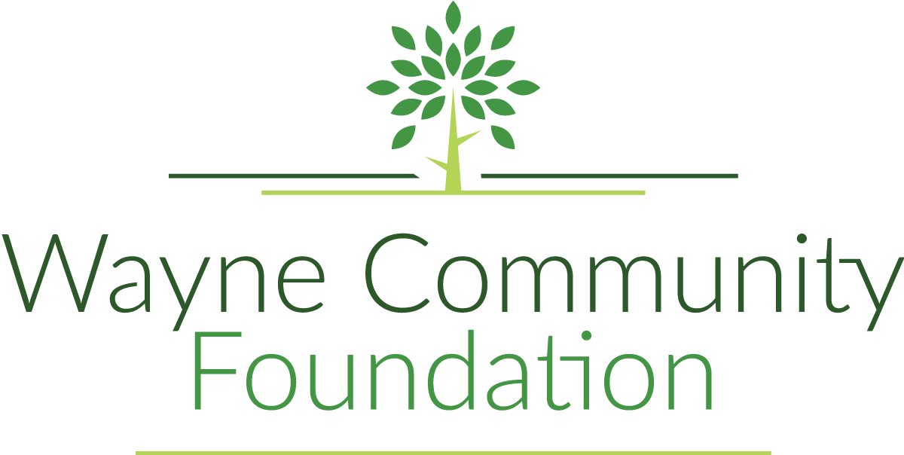

100 N Franklin St. Ste 1

PO Box 82

Corydon, IA 50060

[waynecommunityfoundationiowa@gmail.com](mailto:waynecommunityfoundationiowa@gmail.com)

Grant Application Overview

**Our Purpose:**

The objective of WCF is to receive, invest, and disburse funds, property and gifts of any kind exclusively for the benefit of all citizens in Wayne County. WCF is a 501(c)3 non-profit corporation designed to benefit the areas of education, literature, arts and sciences, recreation, safety and our heritage.

Wayne Community Foundation is affiliated with the Community Foundation of Greater Des Moines, a nationally certified foundation.

**Grant Requirement:**

Applications for grants must be for $1,000 or more.

**Generally Will Not Fund:**

Existing debt, consumable items, operating expenses or salaries

**Application Deadline:**

March 3rd, 2025

Approval + Denial letters sent out the last week of March

Drop off original plus SIX copies when submitting.

**Affiliate Grant Application Contact Information**

Taylor Bloomquist, Foundation Coordinator

[waynecommunityfoundationiowa@gmail.com](mailto:waynecommunityfoundationiowa@gmail.com)

319-316-2073

| **Wayne Community Foundation**  “An Affiliate of the Community Foundation of Greater Des Moines” | | | | | |
| --- | --- | --- | --- | --- | --- |
| **Grant Application – Cover Page** | | | | | |
| Project Title: | | | | | |
| Applicant: | | | | | Federal Tax ID#: |
| Address: | | | | | |
| City: | | State: | | | ZIP Code: |
| Contact Person Responsible for the Project & their Title: | | | | | |
| Contact Phone: | | | Contact Email: | | |
| Fiscal Sponsor(if needed): | | | | | Federal Tax ID#: |
| Address: | | | | | |
| City: | | State: | | | ZIP Code: |
| Project Budget: $ | Amount Requesting: $ | | | | Project Start Date:  Estimated Completion Date: |
| Description of Organization: | | | | | |
| Description of Project: | | | | | |
| Signature: | | | Date: | | |
| **Drop off completed original application and 6 copies by Monday, March 3rd, 2025:**  **Wayne Community Foundation office**  **100 N. Franklin St., Corydon, IA 50060**  **Please reach out to Taylor Bloomquist with questions:**  [waynecommunityfoundationiowa@gmail.com](mailto:waynecommunityfoundationiowa@gmail.com)  641-895-9738 | | | | | |

| **Wayne Community Foundation**  “An Affiliate of the Community Foundation of Greater Des Moines” |
| --- |
| **Grant Application – Questions of Purpose-use additional pages if needed** |
| Describe the need or problem being addressed by this project: |
| Explain how this project will benefit the citizens of Wayne county: |
| Describe the project goals and objectives and describe the steps you will follow to achieve goals and objectives, complete with timeline: |
| What area or population is being served? |
| Will this project have long-term impact? How will this project be sustained? |
| Have you previously received funding from Wayne Community Foundation? If so, when? |

**Project Budget**

**Income**

**Source Amount**

| Donations | $ |
| --- | --- |
| Sponsor Contributions | $ |
| Federal Gov. Grants | $ |
| State Gov. Grants | $ |
| Private Foundations (i.e. Langtry) | $ |
| County Foundation (amount requesting) | $ |
| Other | $ |
| Other | $ |
| Other | $ |
| Other | $ |

**Total:**

**Expenses**

**Source Amount**

| Land Purchase | $ |
| --- | --- |
| Professional Services | $ |
| Construction/Labor Costs | $ |
| Equipment Purchase | $ |
| Construction Supplies | $ |
| Training Costs | $ |
| Other | $ |
| Other | $ |
| Other | $ |
| Other | $ |

**Total:**

***All individual bids, plans, contracts, etc that pertain to this project MUST be attached.

**Drop off completed original application and 6 copies by Monday, March 3rd, 2025:**

**Wayne Community Foundation office**

**100 N. Franklin St., Corydon, IA 50060**

**Please reach out to Taylor Bloomquist with questions:**

[waynecommunityfoundationiowa@gmail.com](mailto:waynecommunityfoundationiowa@gmail.com)

641-895-9738