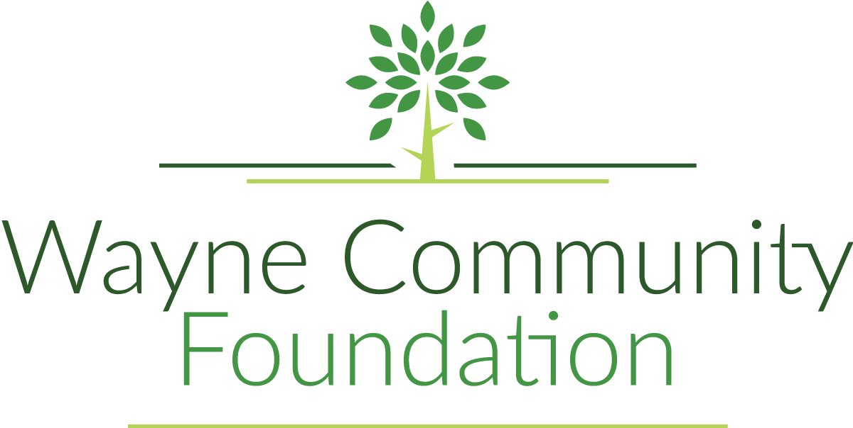

PO Box 82

Corydon, IA 50060

[waynecommunityfoundationiowa@gmail.com](mailto:waynecommunityfoundationiowa@gmail.com)

Seeds for Success Grant Application Overview

The Wayne Community Foundation (WCF) is an organization dedicated to supporting and benefiting the citizens of Wayne County. Our Seeds for Success Grant is designed to help with the initiation or completion of significant projects. The maximum amount that may be requested is $50,000. Seeds of Success projects must demonstrate how they will serve as a catalyst, go above and beyond, and bring innovation to all of Wayne County.

**Grant monies cannot be used to fund the following:**

* Existing debt
* Operating expenses or salaries
* Consumable items

**Application Process:**

Applications are due at 4:00 PM on August 14, 2025

Applications must include both the original paper copy and an electronic copy (on a Flash drive or as an email attachment).

The application review process will be completed by September 30, and all applicants will be notified in writing of the final determination.

**Grant Application Contact Information:**

Ronald Gibbs, Board Member, 928.710.2248 or [rgibbs1073@msn.com](mailto:rgibbs1073@msn.com)

Jenna Lain, President, Wayne Community Foundation, 641.872.1304 [waynecommunityfoundationiowa@gmail.com](mailto:waynecommunityfoundationiowa@gmail.com)

**Eligibility to Apply for Funding:**

**501(c)(3) tax-exempt nonprofit organizations or 170(c)(1) component units of government organizations (Fire Dept., Ambulance, Libraries, Parks, etc.)**

**Organizations providing services within Wayne County.**

**If you are not a 501(c)(3) or a 170(c)(1), you must partner with a fiscal sponsor. The fiscal sponsor must be a 501(c)(3) organization or a government agency that has agreed to receive and disburse the funds on behalf of your organization.**

**The Final Report for all previous grants must be on file before submitting a new grant application.**

| **Wayne Community Foundation**  “An Affiliate of the Community Foundation of Greater Des Moines” | | | | |
| --- | --- | --- | --- | --- |
| **Seeds for Success Grant Application – Cover Page** | | | | |
| Project Title: | | | | |
| Applicant name: | | | | Federal Tax ID#: |
| Street Address: | | | | |
| City: | | State: | | ZIP Code: |
| Contact Person Responsible for the Project & their Title: | | | | |
| Contact Phone: | | | Contact Email: | |
| Fiscal Sponsor (if needed)1: | | | | Federal Tax ID#: |
| Street Address: | | | | |
| City: | | State: | | ZIP Code: |
| Contact person | | Contract phone No.: | | Contact E-mail: |
| Project Budget: $ | Amount Requesting: $ | | | Project Start Date:  Estimated Completion Date: |
| Description of Organization (attached additional pages as needed): | | | | |
| Description of Project (attached additional pages as needed): | | | | |
| Signature: | | | Date: | |
| Drop off the completed original application and an electronic copy  (on a Flash drive or as an email attachment).by Thursday, August 14, 2025:  Wayne Community Foundation office  100 N. Franklin St., Corydon, IA 50060 | | | | |

**1** A fiscal sponsor is neededif the applicant is not a 501(c)3)*.* The fiscal sponsor must be a 501(c) (3) organization or a government agency that has agreed to receive and disburse the funds on behalf of the organization requesting the grant.

| **Wayne Community Foundation**  “An Affiliate of the Community Foundation of Greater Des Moines” |
| --- |
| **Questions of Purpose: Use additional pages as needed, and provide as much detail as possible.** |
| Describe the need or problem being addressed by this project: |
| Explain how this project will benefit the citizens of Wayne County: |
| Describe the project goals and objectives, and describe the steps you will follow to achieve the goals and objectives, complete with a timeline: |
| What area or population is being served? |
| Will this project have a long-term impact? How will this project be sustained? |
| Have you previously received funding from Wayne Community Foundation? If so, when? |

**Project Budget**

**Income**

**Source Amount**

|  |  |
| --- | --- |
| Donations | $ |
| Sponsor Contributions | $ |
| Federal Gov. Grants | $ |
| State Gov. Grants | $ |
| Private Foundations (i.e. Langtry) | $ |
| County Foundation (amount requested) | $ |
| Other | $ |
| Other | $ |
| Other | $ |
| Other | $ |

**Total:**

**Expenses**

**Source Amount**

|  |  |
| --- | --- |
| Land Purchase | $ |
| Professional Services | $ |
| Construction/Labor Costs | $ |
| Equipment Purchase | $ |
| Construction Supplies | $ |
| Training Costs | $ |
| Other | $ |
| Other | $ |
| Other | $ |
| Other | $ |

**Total:**

***All individual bids, plans, contracts, etc. that pertain to this project MUST be attached.

Drop off the completed original application and an electronic copy

(on a Flash drive or as an email attachment) by Thursday, August 14, 2025:

Wayne Community Foundation office

100 N. Franklin St., Corydon, IA 50060